Vermot-Desroches Matthias

Rapport de séance n°7

During this session, I started by using the cutting machine in order to produce the wooden plate based on the modified CAD model that I made last week.

After that, I began to glue the joint and the plate together, but Mr. Masson and Mr. Peter told me that I would need the joint to be 5mm thick and not 3mm. Here is a picture to explain the need to have a thickness:

You can see in this picture that there will be a gap of 2 to 3 mm when the joint is glued to the plate. That is not great to maintain the joint right when the glue is used and is more easily breakable. So, I remade them with 5mm wood.  
Then, I realized that it would be easier to have two joints linked in each corner of the plate. Here is a picture to illustrate:

This configuration allows the ensemble to have a better bending resistance. However, my current joint cannot fit this role, so you can see my “chainons” on the picture as they literally fit to every side but one, the top one. After speaking with the professors, I decided to make a new CAD model to make corner pieces that will be use just like in the picture above.

Here is how they look:

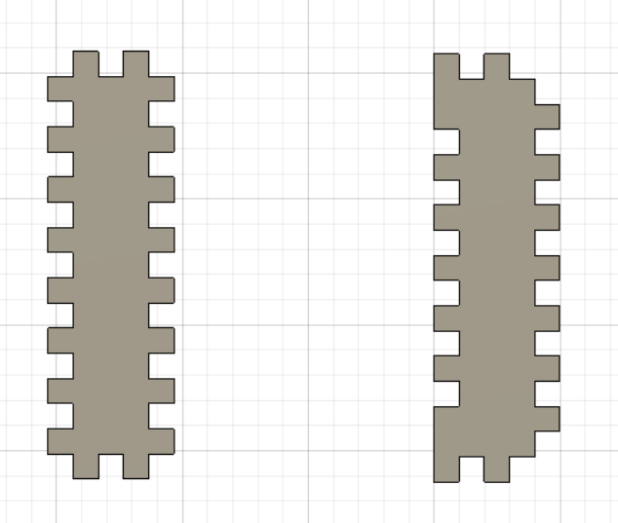

On the left, you can see the female corner piece, which is just a female “chainon” but with a Y axed symmetry.  
On the right, you can see the male corner piece, the weird tooth on the bottom left and top left corner are here to have more space to apply the glue on.

During the end of the session, the cutting machine was used by other groups, so I searched a way to reproduce the final servomotor ensemble after realizing that my “chainon” will probably not be as resistant as I hoped and that they didn’t have enough width. Here is a first idea:

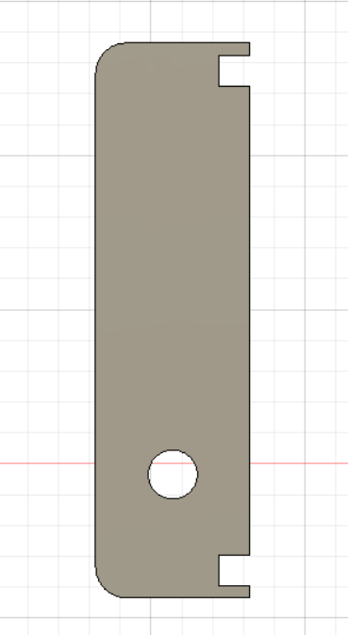

By using two of this piece, and then using a strut with bigger “chainons”, I think we could make a pseudo servomotor group, but this idea will probably change during the next session.